COLAB:

Colaboratory by Google (Google Colab in short) is a Jupyter notebook based runtime environment which allows you to run code entirely on the cloud.

This is necessary because it means that you can train large scale ML and DL models even if you don’t have access to a powerful machine or a high speed internet access.

Google Colab supports both GPU and TPU instances, which makes it a perfect tool for deep learning and data analytics enthusiasts because of computational limitations on local machines.

Since a Colab notebook can be accessed remotely from any machine through a browser, it’s well suited for commercial purposes as well.

## Creating your first .ipynb notebook in colab

Open a browser of your choice and go to [colab.research.google.com](http://colab.research.google.com/) and sign in using your Google account. Click on a new notebook to create a new runtime instance.

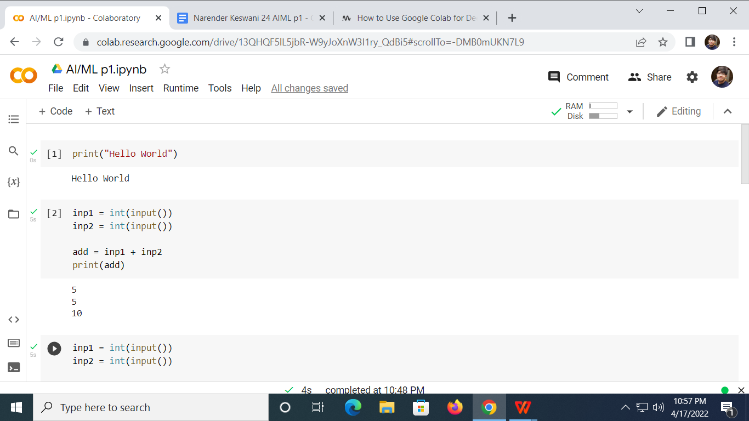

Pros:

* Pre-built with lots of python library
* Quick Start of python learning
* No infra setup required
* No charges for GPU usage
* Can run your code for 24 hrs without interruptions but not more than that
* Your notebooks is saved in google drive only

Cons:

* Need to install all specific libraries which does not come with standard python (Need to repeat this with every session)
* Google Drive is your source and target for Storage, there are other like local (which eats your bandwidth if dataset is big)
* Google provided the code to connect and use with google drive but that will not work with lots of other data format
* Google Storage is used with current session, so if you have downloaded some file and want to use it later, better save it before closing the session.
* Difficult to work with BIGGER datasets as you have to download and store them in Google drive (15 GB Free space with gmail id, additional required a payment towards google)

1. **HELLO WORLD:**

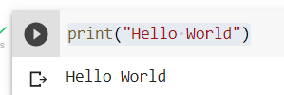

1. **ARITHMETIC OPERATIONS:**
2. **ADDITION:**

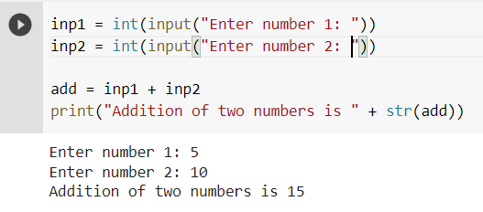

1. **SUBTRACTION:**

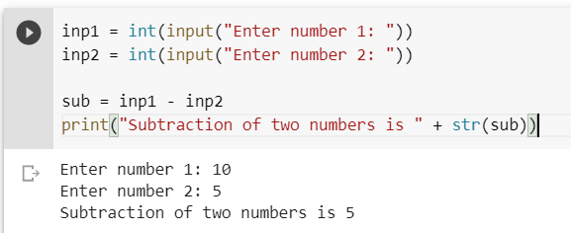

1. **MULTIPLICATION:**

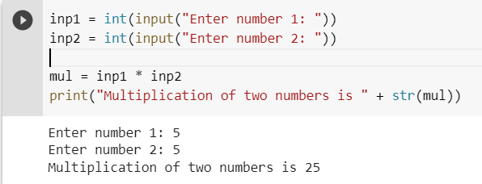

1. **DIVISION:**

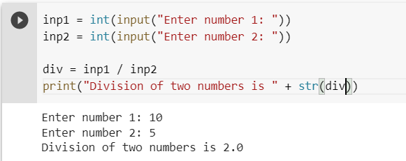

1. **AREA OF CIRCLE:**

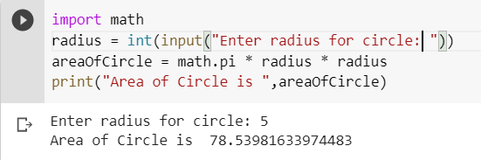

1. **AREA OF TRIANGLE:**

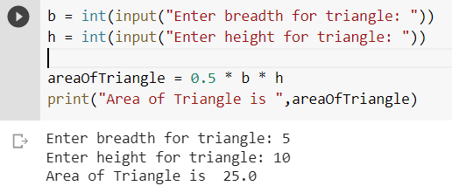

1. **EVEN NUMBERS:**

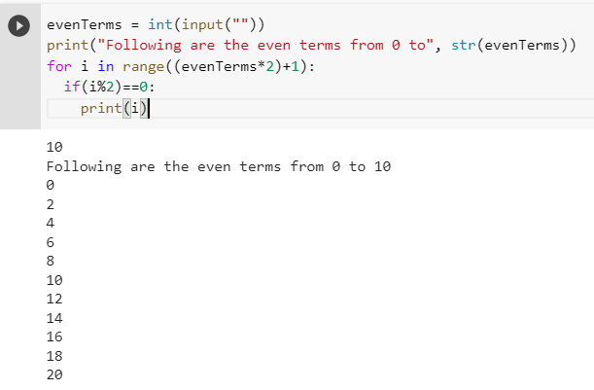

1. **ODD NUMBERS:**

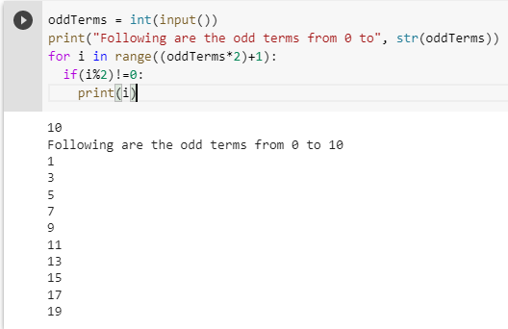

1. **GENERATE MULTIPLICATION TABLE USING LOOPS:**

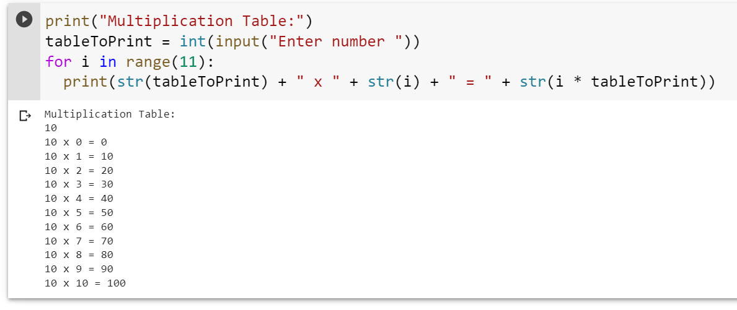

1. **WHILE LOOP:**

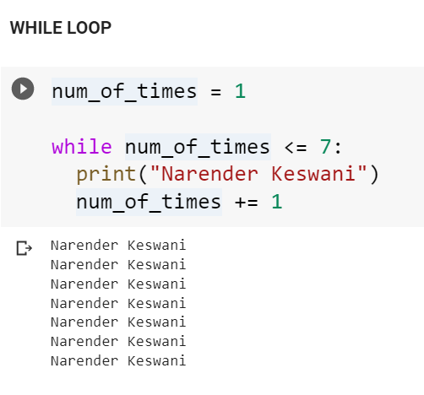

1. **PYRAMID:**

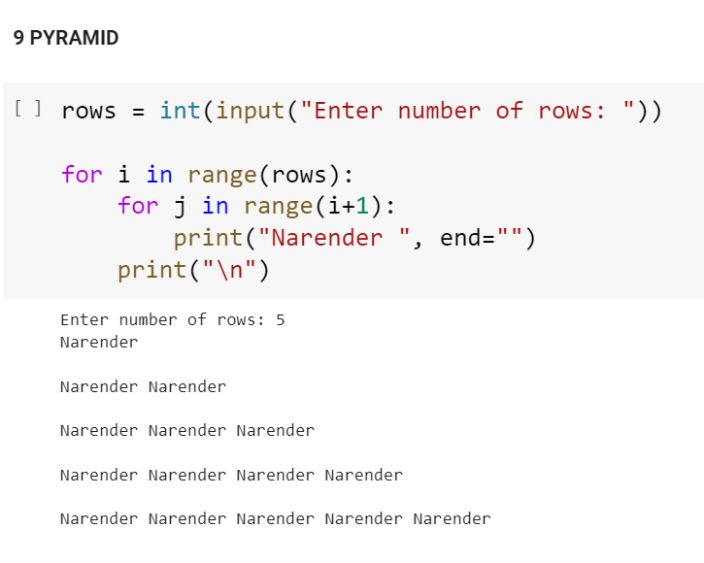

1. **PRIME NUMBER CHECK:**

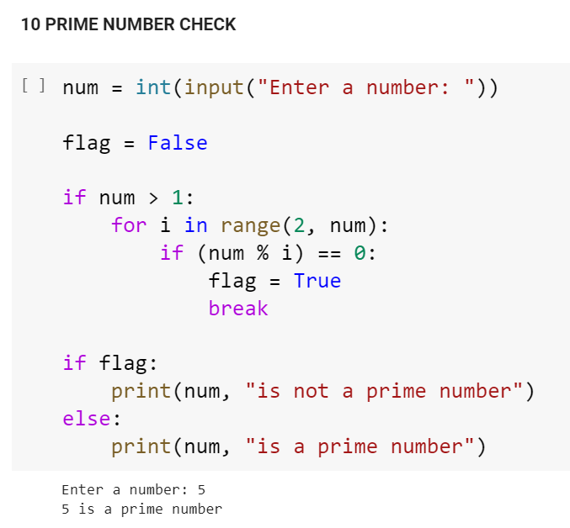

1. **GENERATE PRIME NUMBERS:**

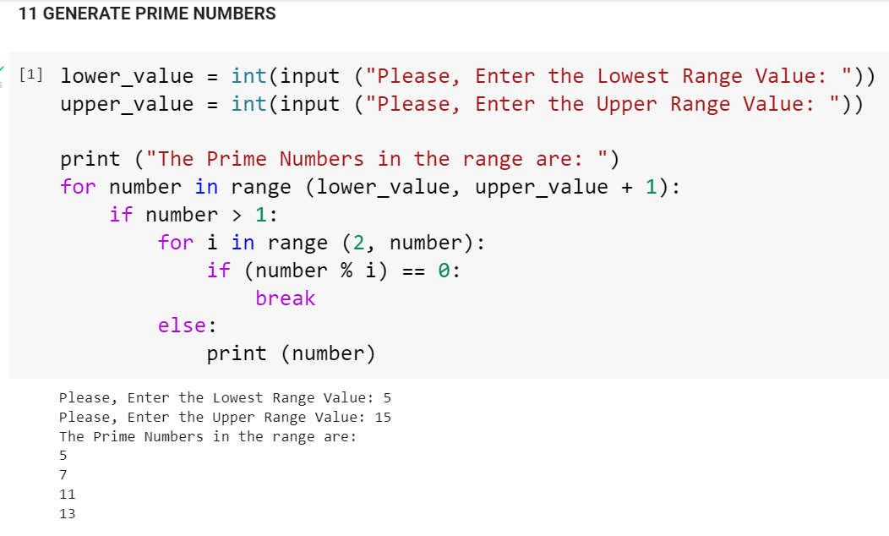

1. **PALINDROME NUMBER CHECK:**

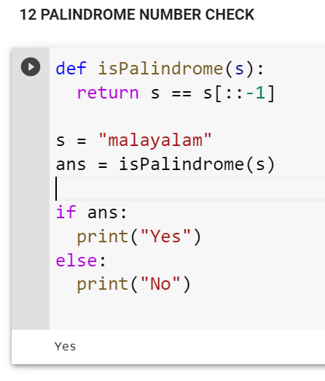

1. **TAKE INPUT FROM USER(ROLL, NAME, DOB, ADDRESS) AND STORE IN ARRAY DATATYPE**

